TDD-FDP-CCE

Design Project
(Technical Design Document)

Project Name | Smart Library Management Design
Student | - Bùi Nguyễn Hưng  - Nguyễn Đức Vĩnh Kiên  - Nguyễn Văn Tấn | ID | 23119009  23119014  23119035
Major | Computer Engineering Technology | Supervisor | Assoc. Prof. Phan Van Ca
CONTENTS
Terms and Abbreviations…………..……………………….………………4
References……………………………………………………...…………….4
List of Tables & Figures………………………………...……....…………..4
1. Introduction………………………………………………...…...……...…6
2. Technical Objectives and Specification…………………….….……...…8
2.1. Customer Needs………………………………………..........……..…8
2.2. Engineering Requirements………...……………….............…………9
2.2.1. Functions…………………………………..……......………….9
2.2.2. Non-functions………….…..….........…………………………10
3. Concept / Technology……….......…………………………...…..………12
3.1. Overview……………………………….......................................….. 12
3.2. Core Technologies………………………………....…………………12
3.3. System Concept ……………………………………….......…............17
4. System Architecture ………………………………...................……......18
4.1. System Block Diagram………………………………...……..…...… 18
4.2. Hardware Block Diagram ……………………....…………....………19
5. Detailed Design……...….…...………….…...……….………...……….. 20
5.1. Flowchart …………………………………………………………….20
5.2. Detailed Hardware …………………………………………………...23
6. Final Product …………………………………………...……………….26
6.1. Presence Detection and Lighting Control Results …………………...26
6.2. Humidity Monitoring and Fan Control Results ……………………...26
6.3. Barcode Scanning and Book Information Display Results ………….26
6.4. Door Control and System Reliability Evaluation…………………… 27
7. Appendix ……………………………………………………...…………28
7.1. Division of Labor …………………………………...……………….28
7.2. Bill of Material……………………………………........…………… 30
7.3. User Manual …………………………………………………………31

Terms and abbreviations

[UART] | Universal asynchronous receiver-transmitter.
[USB] | Universal Serial Bus.
[CPU] | Central Processing Unit
[ADC] | Analog-to-Digital Converter
[ESP32] | 32-bit Wi-Fi and Bluetooth Microcontroller by Espressif
[GPIO] | General Purpose Input/Output
[I2C] | Inter-Integrated Circuit
[LCD] | Liquid Crystal Display
[VDC] | Volt Direct Current

- References

[1] Espressif Systems, ESP32 Series Datasheet, Espressif Systems, 2023.
[2] Aosong Electronics Co., Ltd., DHT22 (AM2302) Digital Temperature and Humidity Sensor Datasheet, 2022.
[3] Hitachi, HD44780U LCD Controller/Driver Datasheet, Hitachi Ltd., 1998.
[4] MH-ET LIVE, Barcode Scanner Module V3.0 User Manual, MH-ET LIVE, 2021.
[5] Devantech Ltd., SRF05 Ultrasonic Ranger Technical Documentation, 2019.
[6] Texas Instruments, LM2596 SIMPLE SWITCHER® 3A Step-Down Voltage Regulator Datasheet, Texas Instruments, 2020.
[7] FreeRTOS, FreeRTOS Documentation, available online.

- List of Tables & Figures
Figure 1: ESP32
Figure 2: DHT22
Figure 3: LCD
Figure 4: SRF05
Figure 6: Step-down
Figure 7: Scanner
Figure 8: Relay
Figure 9: Led
Figure 10: System Block Diagram
Figure 11: Hardware Block Diagram
Figure 12: Flowchart task presence detection and door control
Figure 13: Flowchart humidity monitoring and fan control
Figure 14: Flowchart barcode scanning and access control
Table 1: Division of Labor
Table 2: Bill of material

Introduction

- Nowadays, with the rapid development of information technology and the ongoing digital transformation in education, library systems are increasingly required to provide fast, accurate, and efficient services to support a growing number of users. However, many small- and medium-sized libraries, such as university libraries, academic clubs, and self-study rooms, are still managed using manual methods, including handwritten records or basic spreadsheet-based tools. These traditional approaches are inefficient, prone to human error, and unable to support real-time processing or concurrent access.

- Common issues in manual library management include inconsistencies in book inventory data, delays in borrowing and returning operations, difficulties in tracking overdue books, and the absence of real-time synchronization between librarians, bookshelves, and management systems. As the number of users and library resources increases, these limitations become more critical, resulting in longer waiting times, misplaced or lost books, and reduced user satisfaction. Furthermore, manual management systems are not designed to handle concurrent operations, which are essential for modern library environments.

- To address these challenges, this project proposes the design and implementation of a Smart Library Management System based on a Real-Time Operating System (RTOS). The use of RTOS enables the system to execute multiple tasks concurrently under strict timing constraints, including book searching, borrowing and returning processes, user management, and overdue book monitoring. Core RTOS mechanisms such as task scheduling, inter-task communication, and synchronization techniques—namely queues, mutexes, semaphores, and software timers—are employed to ensure data consistency, reliability, and deterministic system behavior.

- The proposed system integrates embedded hardware components, including a microcontroller, a barcode scanning module, an LCD display, and smart bookshelf indicator lights. A dedicated timer task continuously tracks borrowing durations, detects overdue books in real time, and generates timely alerts to notify users and administrators of violations.

- Through this project, fundamental RTOS concepts—multitasking, task prioritization, resource sharing, and deterministic response—are applied to a practical library management application. The proposed system aims to enhance operational efficiency, reduce manual workload, improve data accuracy and scalability, and ultimately provide a more reliable and user-friendly library service.

Technical objectives and Specification

Customers Needs
Efficient and Accurate Book Management
- Library staff require a system capable of accurately tracking the real-time status of books, including available, borrowed, and overdue states.

Fast and Convenient Borrowing–Returning Process
- Users need a quick and user-friendly borrowing and returning process with minimal waiting time, even during peak hours.
- The system must be able to handle multiple concurrent requests without data conflicts.

Overdue Monitoring and Notification
- An automated mechanism is required to precisely monitor borrowing durations and accurately detect overdue books.
- Timely notifications should be issued to both librarians and users.

Reduction of Manual Operations and Human Errors
- Automation helps save time, reduce human errors, and significantly improve overall operational efficiency.

Scalability and Cost Effectiveness
- The system should be easily scalable to support an increasing number of books, users, and shelves without requiring a complete system redesign.
- This approach helps reduce losses, enhance service quality, and ensure long-term sustainability.

2.2 Engineering Requiments
2.2.1 Funtions

Sensor Functions
- Measure temperature and humidity using the DHT22 sensor.
- Detect human presence using the SRF05 ultrasonic sensor.
- Periodically update sensor data.
- Transmit collected data to the ESP32 for processing.

Control Functions
- Process data using RTOS-based tasks.
- Turn on lights when human presence is detected.
- Trigger warnings when environmental parameters exceed predefined thresholds.

User and Book Management
- Search, borrow, and return books.
- Update book status in real time.
- Track borrowing duration using software timers.

User Interface
- Display system information on the LCD 2004A.
- Show overdue time information.

Data Handling
- Store shared data resources.
- Use queues to transmit requests between tasks.
- Use mutexes and semaphores to prevent resource conflicts.

Maintenance and Safety
- Automatically recover tasks in case of failure.
- Detect sensor malfunctions.
- Modular design for easy system expansion.

2.2.2 Non-functions
Reliability
- The system must operate continuously for at least 4–6 hours without deadlock or RTOS task freezing.
- Sensor data (DHT22, SRF05) must be updated accurately.
Availability-
- The system must achieve an uptime of at least 95% under normal operating conditions.
- Important functions such as:
+ Human detection.
+ Light activation.
+ Environmental warnings.
- Must always be available to users.
- The system must automatically recover after a power outage or ESP32 reset.
Performance
- The response time when human presence is detected (SRF05 → light on) must be ≤ 100 ms.
- The time to update sensor data and display it on the LCD must be ≤ 500 ms.
- Data transmission between tasks via queues must ensure low latency and must not cause system congestion.
Scalability
- The system allows easy:
+ Addition of new sensors (light, CO₂, RFID…)
+ Addition of RTOS tasks without changing the overall system structure.
- The number of users and books can be expanded without affecting system performance.

Security
- Only authorized users are allowed to:
+ Borrow/return books.
+ Update book status.
- Borrowing data and overdue time information must be protected from unauthorized access.
- Access control between tasks is applied to reduce the risk of data conflicts.
Safety and Fault Handling
- The system must detect and report errors when:
+ The DHT22 or SRF05 sensor operates abnormally.
+ No data is received within a specified period of time.
- When environmental parameters exceed safe thresholds, the system must:
+ Trigger warnings.
+ Display clear information on the LCD.
Maintainability
- The system is designed in a modular manner (sensor, control, UI, data handling) to:
+ Facilitate debugging.
+ Simplify firmware upgrades.
- The source code has a clear structure and is easy to read and modify.
- The system supports firmware updates for the ESP32 when necessary.
Usability
- The LCD 2004A interface must:
+ Clearly display humidity information.
+ Present overdue book information in an easy-to-understand manner.
- The system operates automatically and does not require complex user interaction.

Concept/Technology

Overview
- The proposed Smart Library Management System applies embedded system design and Real-Time Operating System (RTOS) technology to automate library operations such as book borrowing, returning, searching, and environmental monitoring. The core of the system is the ESP32 microcontroller, which runs FreeRTOS to manage multiple concurrent tasks with deterministic timing. In addition to library management functions, DHT22 temperature and humidity sensor is integrated to monitor environmental conditions, helping protect books from excessive humidity or temperature.
- By combining RTOS-based multitasking with sensor monitoring, the system ensures fast response, reliable data handling, and stable operation even when multiple users interact with the library simultaneously.

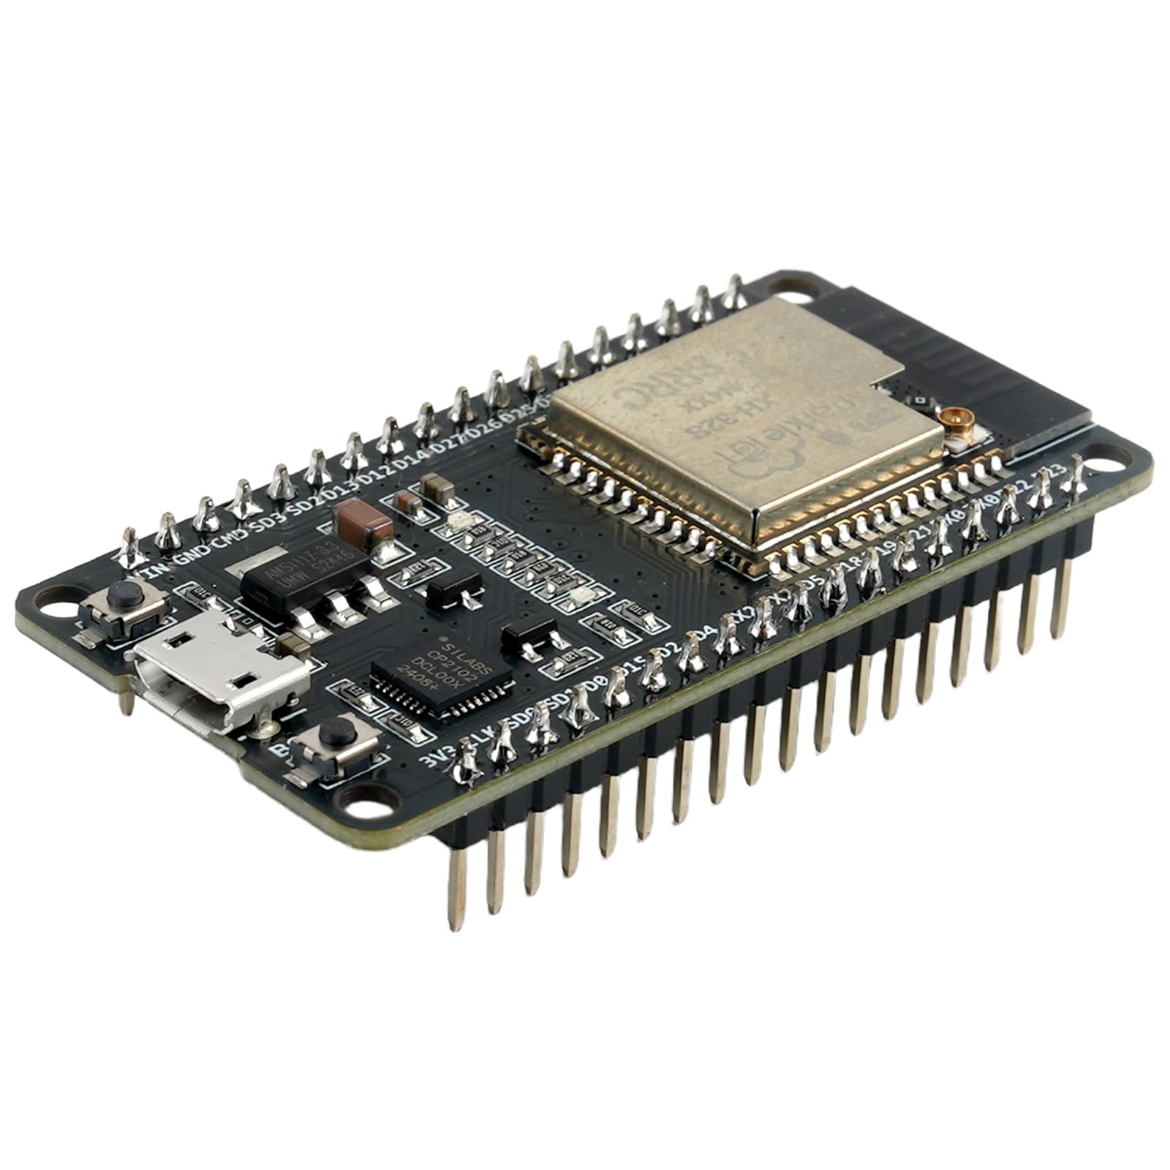Core Technologies
ESP32
- CPU: Dual-core Tensilica LX6, up to 240 MHz
- Flash: 4 MB
- RAM: 520 KB SRAM
- Wi-Fi: 802.11 b/g/n (2.4 GHz)
- Bluetooth: v4.2 BR/EDR and BLE
- Operating Voltage: 3.0–3.6 V
- Digital I/O Pins: 30+ (varies by board version)

Figure 1: ESP32

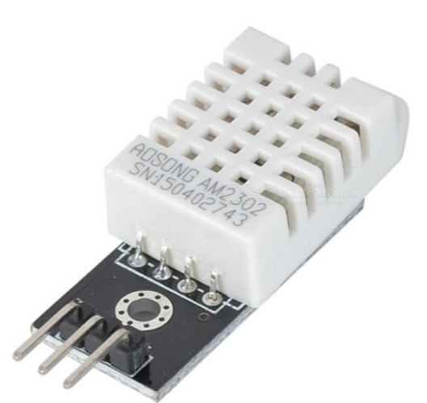DHT22
- Temperature Range: 0 °C to 50 °C
- Temperature Accuracy: ±2 °C
- Humidity Range: 20–90% RH
- Humidity Accuracy: ±5% RH
- Operating Voltage: 3.3–5V
- Communication: Single-wire digital protocol

Figure 2: DHT22
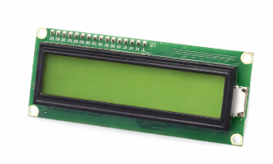
LCD 16x4 Character Display
- Display: 16 characters × 4 lines
- Interface: Parallel (HD44780) or I2C (with module)
- Operating Voltage: 5 V
- Backlight: LED (adjustable brightness)
- Character Size: 5×8 dot matrix

Figure 3: LCD

SRF05 Ultrasonic Sensor (Ultrasonic Distance Measuring Module)
- Measures distance and calculating the time of flight of the reflected echo signal.
- 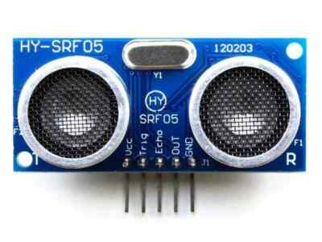Measuring range: 3 cm – 400 cm.
- Measuring angle: Approximately 15°.
- Operating voltage: 5 V DC.
- Output signal: Digital pulse (Echo) proportional to distance.
- Trigger signal: 10 µs TTL pulse (Trigger).
- Measurement resolution: Approximately 3 mm.
- Interface: Digital signals (Trigger and Echo via GPIO). Figure 4: SRF05

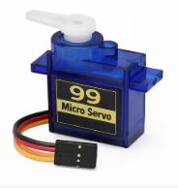Micro Servo 9g
- A small servo motor controlled by PWM signals to rotate to a specific angle
- Operating voltage: 4.8 – 6 V
- Control signal: PWM (Pulse Width Modulation)
- Rotation angle: Typically 0° – 180°
- Torque: Approximately 1.8 kg·cm
- Control the opening and closing of the door
Figure 5: Servo

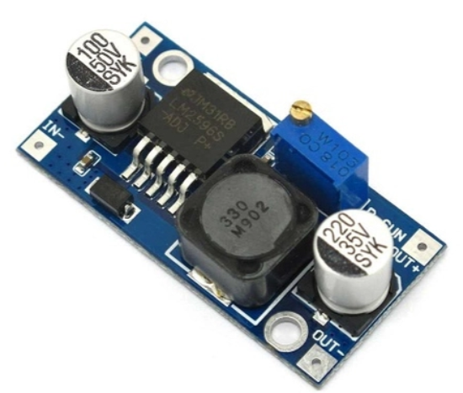LM2596 DC–DC Buck Converter 3A
- Step-down (buck) DC–DC switching regulator
- Input voltage range: 4 – 40 V DC
- Output voltage range: 1.25 – 35 V DC (adjustable)
- Maximum output current: Up to 3 A
- Conversion efficiency: Up to 90%
- Reduce and regulate input voltage to supply stable power for system components

Figure 6: Step-down

MH-ET LIVE Barcode Scanner Module V3.0
- 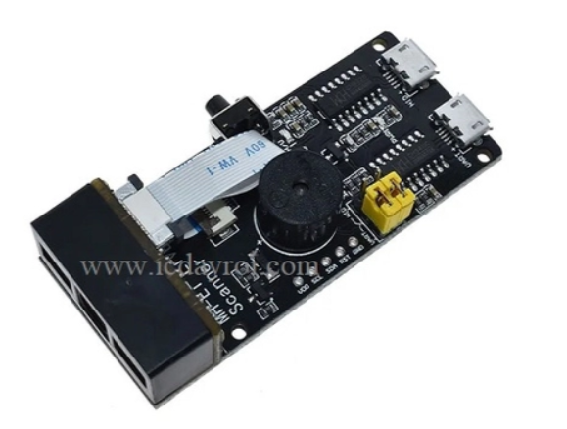Function: 1D barcode scanning and decoding module
- Operating voltage: 3.3 – 5 V DC
- Interface: UART (TTL serial)
- Output data: ASCII string
- Scanning distance: ~3 – 30 cm
- Indicator: On-board LED and buzzer
- Used to scan book barcodes and provide data for book identification and access control
Figure 7: Scanner

2-Relay 5V Opto-Isolated Module (H/L Trigger)
- Function: Dual-channel relay module for controlling AC/DC loads
- 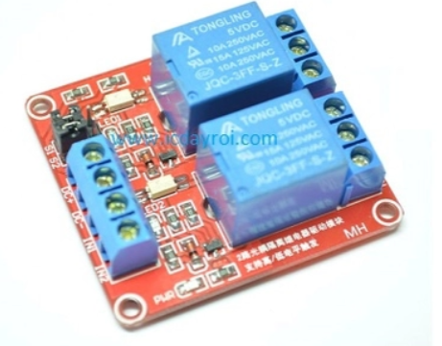Operating voltage: 5 V DC
- Trigger type: High-level / Low-level trigger (H/L selectable)
- Isolation: Opto-isolated input for MCU protection
- Relay rating: 10 A @ 250 VAC / 10 A @ 30 VDC
- Interface: Digital GPIO control
- Application: Used to switch the cooling fan and other external loads safely. Figure 8: Relay

RGB LED Module
- 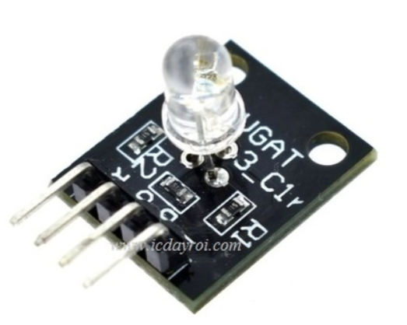Function: Provides visual status indication using red, green, and blue light.
- Operating voltage: 3.3 – 5 V DC.
- Interface: Digital GPIO control (individual R, G, B pins).
- Output: Red, green, blue, or mixed colors depending on control signals.
- Control method: Logic HIGH/LOW or PWM signals for color and brightness control.
- Indicator: On-board RGB LED.
- Used to indicate system status such as access granted Figure 9: Led
, access denied, system standby, or error conditions.

System Concept
- The DHT22 sensor continuously measures temperature and humidity inside the library to monitor environmental conditions.
- The ESP32 processes sensor data and manages system operations using FreeRTOS, allowing multiple tasks to be executed concurrently.
- The SRF05 ultrasonic sensor detects human presence or motion near the bookshelves to trigger system interaction or automatically activate shelf lighting.
- The Micro Servo 9g is used to control the automatic door opening and closing mechanism, ensuring access control based on book status.
- The LM2596 DC–DC Buck Converter 3A is responsible for stepping down and stabilizing the supply voltage, providing appropriate power for system modules and actuators.
- System status, environmental data, and book information are displayed in real time on the LCD 2004A.
- The barcode scanner reads book barcodes and sends decoded data to the ESP32 via UART for book identification and access control.
- The relay module is used to safely control external loads, such as the cooling fan, from the ESP32. Opto-isolation provides electrical protection, while the H/L trigger allows flexible control via GPIO signals.
- Book management, overdue status checking, and user interaction functions are handled concurrently, ensuring fast, stable, and reliable system operation.

System Architecture

Block Diagram

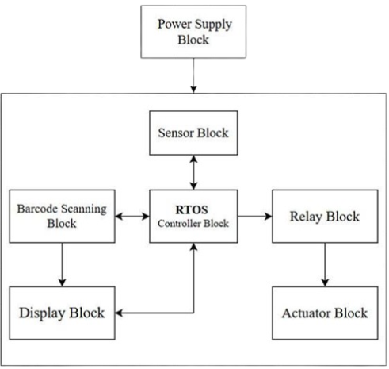

Figure 10: System Block Diagram

Hardware Block Diagram

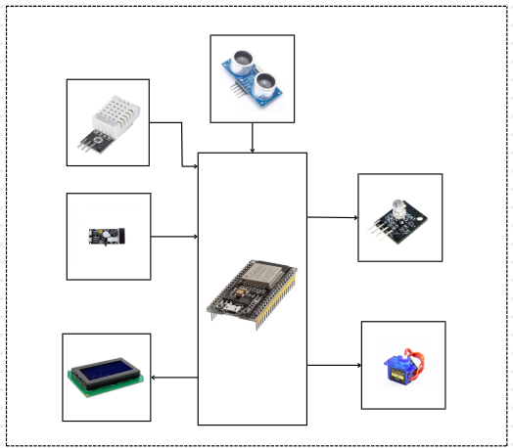

Figure 11: Hardware Block Diagram

Detailed Design

Flowchart
Task 1: Flowchart task presence detection and door control
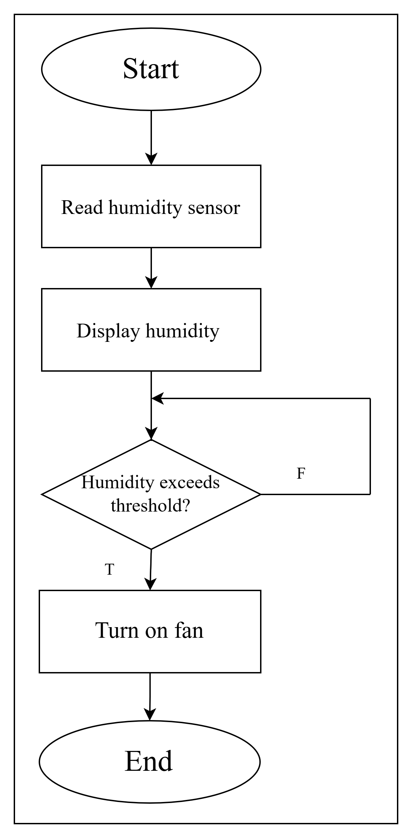

Figure 12: Flowchart task presence detection and door control

Task 2: Flowchart humidity monitoring and fan control

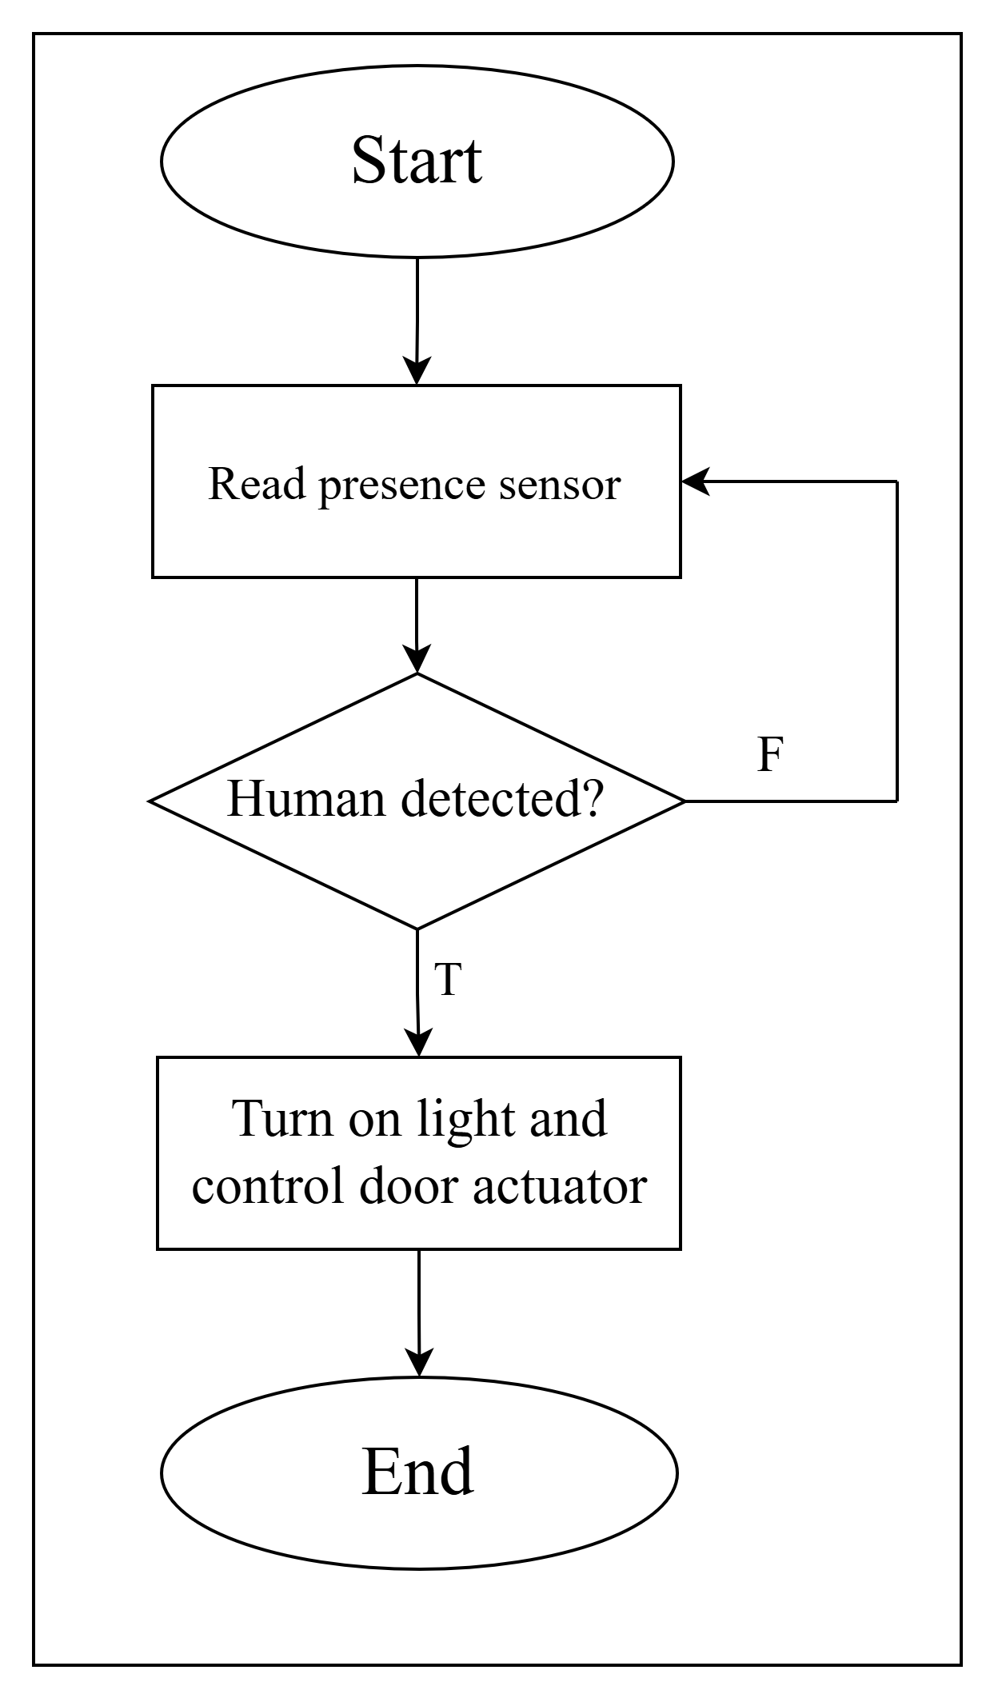

Figure 13: Flowchart humidity monitoring and fan control

Task 3: Flowchart barcode scanning and access control

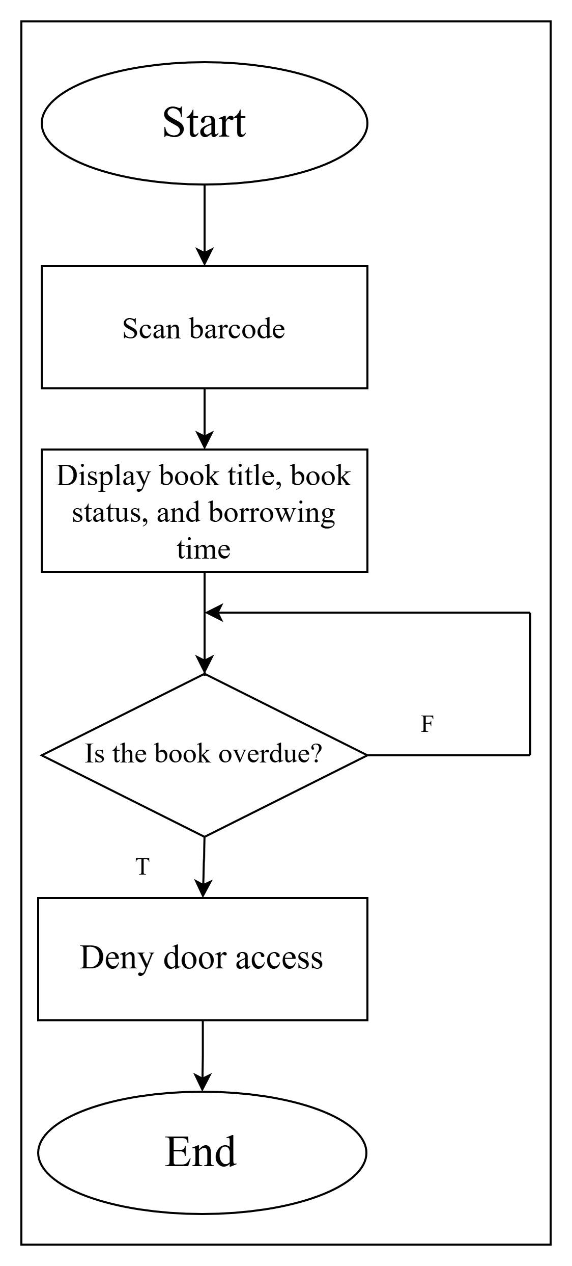

Figure 14: Flowchart barcode scanning and access control

Detailed Hardware
a. ESP32 Microcontroller
- Reason for Selection:
ESP32 is selected for its dual-core processor, high clock speed, and large memory capacity. It supports multiple communication interfaces such as UART, I2C, SPI, and PWM, making it suitable for multitasking and real-time embedded applications.
- Why Other Options Were Not Selected:
Arduino Uno and ATmega-based boards have limited processing power and memory. ESP8266 has fewer GPIO pins and limited multitasking capability.

b. DHT22 Temperature and Humidity Sensor
- Reason for Selection:
DHT22 offers higher accuracy and a wider humidity measurement range compared to basic sensors. It uses a simple single-wire digital communication protocol.
- Why Other Options Were Not Selected:
DHT11 provides lower accuracy and a narrower operating range. More advanced sensors are unnecessary for this project.

c. LCD 2004A (20×4 Character Display)
- Reason for Selection:
The LCD 2004A provides a larger display area, allowing multiple parameters and system messages to be shown simultaneously. It supports I2C interface, which reduces GPIO usage.
- Why Other Options Were Not Selected:
LCD 1602 displays limited information. OLED displays are more expensive and less suitable for long-term static display.

d. Relay Module (5V)
- Reason for Selection:
The 5V relay module allows safe control of high-current loads using low-voltage control signals and provides electrical isolation through optocouplers.
- Why Other Options Were Not Selected:
Direct GPIO control cannot handle high current. Solid-state relays are more costly and unnecessary for low-frequency switching.

f. Micro Servo Motor (9g)
- Reason for Selection:
The 9g micro servo motor is compact, lightweight, and provides precise angular control using PWM signals.
- Why Other Options Were Not Selected:
DC motors require motor drivers and feedback mechanisms, making them more complex to control.

e. MH-ET LIVE Barcode Scanner Module V3.0
- Reason for Selection:
The MH-ET LIVE scanner V3.0 provides fast and accurate barcode scanning with UART communication and simple integration with microcontrollers.
- Why Other Options Were Not Selected:
Camera-based barcode recognition requires higher processing power and complex image processing algorithms.

g. SRF05 Ultrasonic Sensor
- Reason for Selection:
The SRF05 ultrasonic sensor offers reliable distance measurement with good accuracy and stable performance for presence detection.
- Why Other Options Were Not Selected:
Infrared sensors are sensitive to ambient light, and PIR sensors cannot measure distance.

h. LM2596 DC–DC Buck Converter (3A)
- Reason for Selection:
LM2596 is selected for its high efficiency, wide input voltage range, and ability to supply up to 3A of current, suitable for powering multiple modules.
- Why Other Options Were Not Selected:
Linear regulators are inefficient and generate excessive heat. Lower-current buck converters may not support peak load conditions.

Final Product
6.1. Presence Detection and Lighting Control Results
- The proposed system employs a motion detection sensor interfaced with an ESP32 microcontroller to detect human presence. When a person enters the detection range, the sensor triggers the system to activate an LED indicator, signaling the detected presence. In the absence of human motion, the LED is automatically deactivated.
- Experimental tests were conducted at multiple distances within the sensor’s operating range. The system exhibited consistent and reliable detection performance, with a response time typically below 100 ms.
- These results confirm that the ESP32-based presence detection module satisfies the functional requirements for automatic lighting control in smart embedded systems.

6.2. Humidity Monitoring and Fan Control Results
- Environmental monitoring is achieved using a DHT22 humidity sensor connected to the ESP32. The sensor continuously measures ambient humidity, and the measured values are displayed in real time on a 2004A LCD module.
- During experimental evaluation, the humidity readings remained stable within the operating range of 20% to 90% RH. When the measured humidity exceeded a predefined threshold, the ESP32 activated a cooling fan through a relay module. Once the humidity level returned to the acceptable range, the fan was automatically turned off.
- The experimental results demonstrate that the humidity monitoring and fan control subsystem operates accurately and reliably, providing effective environmental regulation.

6.3. Barcode Scanning and Book Information Display Results
- The system integrates a barcode scanning module to identify books and retrieve corresponding information. Upon successful barcode scanning, the ESP32 processes the received ASCII data and displays the book title, availability status, and borrowing condition on the LCD screen.
- Experimental results indicate that the barcode scanner accurately decodes standard one-dimensional barcodes with a response time of less than 300 ms. The system reliably distinguishes between available and unavailable books, as well as between on-time and overdue borrowing states.
- These findings validate the effectiveness of the barcode scanning module for fast and reliable book identification in smart access control applications.

6.4. Door Control and System Reliability Evaluation
- The door access mechanism is implemented using a servo motor controlled by the ESP32. After barcode verification, the system evaluates the borrowing status of the scanned book. If the book is not overdue, the servo motor rotates to open the door; otherwise, the door remains closed and a warning message is displayed on the LCD screen.
- Experimental evaluation shows that the servo motor rotates from the closed position to the open position (approximately 90°) within 1–2 seconds. The servo operation remains stable and repeatable across multiple test cycles.
- The overall system response time, measured from initial presence detection to complete door opening, is approximately 2–3 seconds. No unintended door activation was observed during testing, indicating a high level of operational reliability.
- In summary, the experimental results demonstrate that the proposed ESP32-based smart access control system operates reliably, with fast response times and stable performance, making it suitable for practical deployment in intelligent library and embedded access control environments.

Appendix

Division of Labor

Table 1: Division of Labor
ID | Activity | Description | Deliverables | Duration (Days) | Personnel | Resources
1 | System Requirement Analysis | Analyze functional and non-functional requirements of the smart library system | System requirement specification | 1 | All members | Project description, reference materials
2 | Overall System Design | Design the system block diagram and RTOS-based software architecture | System block diagram | 1 | Hưng, Kiên | RTOS documentation
3 | System Design and Integration | Design the power system using LM2596 and integrate sensors, display, barcode scanner, and actuators | Stable and functional hardware system | 3 | Kiên, Tấn | ESP32, LM2596, DHT22, SRF05, LCD 2004A, Servo 9g, relay, fan, RGB LED, barcode scanner
4 | RTOS Software Development | Develop FreeRTOS tasks for presence detection, environmental monitoring, book management, display handling, and door control | Fully functional RTOS tasks | 2 | All members | ESP32, FreeRTOS
5 | Hardware–Software Integration | Integrate RTOS software with hardware components and synchronize system functions | Fully integrated system | 1 | All members | Complete system
6 | System Testing and Evaluation | Test presence detection, humidity monitoring, fan control, barcode scanning, and door operation | System test report | 1 | Hưng, Tấn | Test scenarios
7 | Documentation and Final Report | Prepare technical documentation and user manual | Completed project report | 2 | All members | Word processor, diagrams

Bill of Material
Table 2: Bill of material

ID | Parts / Components | Quantity | Price per Unit (VND) | Total (VND)
1 | ESP32 Development Board | 1 | 132,000 | 132,000
2 | DHT22 Temperature & Humidity Sensor | 1 | 50,000 | 50,000
3 | 5V LED (single LED 5mm) | 1 | 3,000 | 3,000
4 | LCD 2004A (20x4 Character LCD, I2C) | 1 | 90,000 | 90,000
5 | 5V Cooling Fan | 1 | 22,000 | 22,000
6 | 5V Relay Module | 1 | 32,000 | 32,000
7 | RGB LED Module (3 colors) | 1 | 15,000 | 15,000
8 | SRF05 Ultrasonic Sensor | 1 | 35,000 | 35,000
9 | Micro Servo 9g (SG90) | 1 | 90,000 | 90,000
10 | LM2596 DC–DC Buck Converter 3A | 1 | 25,000 | 25,000
11 | MH-ET LIVE Barcode Scanner Module V3.0 | 1 | 520,000 | 520,000
12 | Male-to-Female Jumper Wire | 20 | 2,000 | 40,000
13 | Female-to-Female Jumper Wire | 20 | 2,000 | 40,000
14 | Male-to-Male Jumper Wire | 20 | 2,000 | 40,000
Total |  |  |  | 1.134.000

User manual
a. Power On
- Supply power to the ESP32 system.
- The LCD 2004A displays the system’s initial status.

b. Presence Detection
- When a person is detected, the RGB LED turns ON.
- When no presence is detected, the RGB LED turns OFF automatically.

c. Humidity Monitoring
- The DHT22 sensor measures environmental humidity.
- The humidity value is displayed on the LCD.
- If the humidity exceeds the preset threshold, the cooling fan is activated via the relay.
- The fan turns OFF when the humidity returns to a safe level.

d. Barcode Scanning
- Place the book barcode in front of the barcode scanner.
- The LCD displays:
+ Book name
+ Book availability status
- Borrowing status (on-time or overdue)

e. Door Control
- If the book is not overdue, the servo motor opens the door.
- If the book is overdue, the door remains closed and a warning message is shown on the LCD.

f. System Notes
- The system operates automatically without manual control.
- Users only need to approach the system and scan the book barcode.

